PFC - Workshop 7

Words processing
Write a menu driven program with the options below:
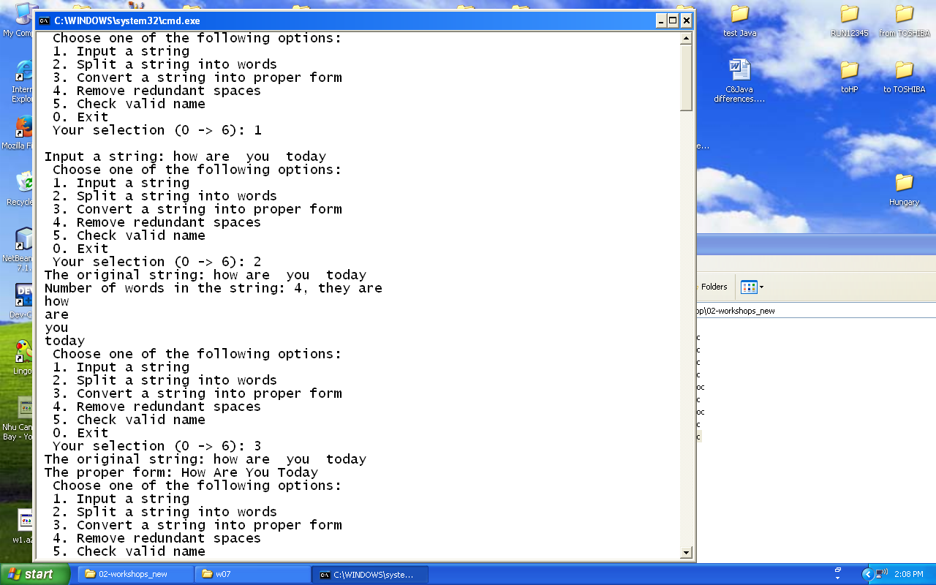
Sample input and output:

